Wise Words: Torment
Gary Wise
Tuesday, February 19, 2002
It seems like every few months I'm using this space to tell the world why it is I love the newest set for the purposes of Limited play. The problem with repeating this action time and again is that the value of my enthusiasm may be lowered.
The reason I'm worried about just such an eventuality is because of how much I do appreciate Torment. It seems over the last year, R&D has made the conscious decision to make Magic the equivalent of three dimensional chess, because the game is now being played on more levels than it ever has been. This time last year, we were learning about the difficulties involved with opposing colors. Three months ago, we found our once passive graveyards being exploited like never before and now... well, now, we have a whole new game.
There are a lot of things I like about this set, more than I'll list here (Have to save some material for other articles, don't I?), but here are ten reasons I'm finding Torment to be as refreshing and interesting a draft set as I've seen in a long time. I hope you'll agree that they provide a lot to be enthusiastic about.
1) Unbalanced colors
Hey, if you want your game to stay interesting and fresh, you've got to expect a certain amount of change. The unbalancing of colors, namely the strengthening of black and weakening of white and green has proved the cause of entire new problems for the best drafters in the world to conquer. Do you force black knowing you'll see dividends in the third pack or do you decide to not clash with six other black players, choosing instead to play the metagame deck? To that end, when you draft white, how highly should you value anti-black cards, and do previously sideboard-able anti-black cards become main deck viable? These are the questions the world will try to answer over the next year, and I for one am pretty sure I'll have a good time doing it.
2) Madness
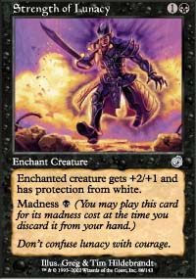
If you want fresh, you have to explore the previously unexplored. Odyssey took care of the graveyard, and the rest of the game's history delved into the possibilities in the hand, library, life total and the field of play, but aside from Dodecapod, and cards that similarly react when an opponent forces you to discard, the possibility of forcing yourself to discard has never really been fully breached.
Well, now it has been. If you find some way of drawing and discarding, that discarding becomes an entirely new kind of card advantage. You'll know the first time you discard Strength of Lunacy to Patchwork Gnomes while they block with a 4/4 fatty that we're all stumbling across something entirely new, which is not only representative of a superlative creative effort from R&D, but also really, really powerful. I don't need to tell you that cards like Basking Rootwalla and Circular Logic will see Constructed play, but they'll be even more interesting in Limited, where there are plenty more ways to exploit them.
3) New coming into play abilities
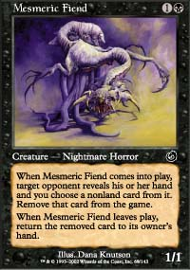
Faceless Butcher really is grotesque, isn't it? Seems like every time I turned around at Grand Prix-Heidelberg, someone was getting their face kicked in by the 'new Nekrataal' that can seldom be killed thanks to a black body and a toughness of three. Thing is, there are new black creatures depriving opponents of all kinds of resources around now, with the Scourge and Mesmeric Fiend wrecking hopes and dreams and even Gravegouger doing some surprising damage.
Every other color seems to have a couple of interesting coming into play abilities, but black really takes the cake, stealing graveyard cards, life points, cards in hand and the like. Red's Petravark is surprisingly good and behaves suspiciously like a black creature in this set, but regardless of color, whenever you take something from an opponent while getting a body in the process, it's bound to be a good thing.
4) The further redefining of the importance of the graveyard
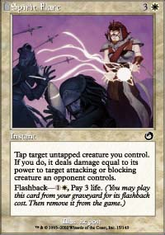
With Odyssey there came an explosion of graveyard use, and there are people in this world who would have been content to leave it at that, but fortunately for us, those people don't work in R&D. With new flashback and threshold cards, the graveyard has stayed just as important in Torment as it was in Odyssey, and now there are even cards whose sole design it is to get more cards in the graveyard. The more the focus of the game is taken from the actual field of play, the more diverse and complex the game gets. That's a very good thing for those of us looking for a challenge when we sit down with a deck in hand.
5) The obscuring of card advantage
Anyone noticed lately that card advantage isn't what it used to be? Once upon a time, card advantage was the measuring stick by which we measured out success (after wins and losses of course), with a hand full of cards to your opponent's none with parity achieved on the table meant certain success. Things aren't so black and white any more.
Simply, with cards like the Rites out there, we've been taught that card disadvantage in exchange for the heightening of the game's other resources can be worthwhile, and with undoable card advantage like Faceless Butcher and Mesmeric Fiend around, not to mention the obscuring of card advantage and disadvantage done by Cephalid Looter and Compulsion, it's pretty difficult to figure out whose beating who in the arms race these days. I love that: it forces us to figure out more creative paths to victory.
6) Flashback at a cost
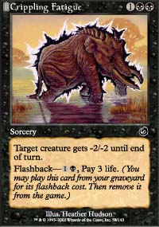
One way that the game has frustrated me over the years is the refusal to diversify certain abilities. Why wasn't there a cycling: 3 or cycling: 1 or cycling: pay two life? Unfortunately, we don't have the answers available to us, and in my eyes, those oversights are lost opportunities.
One fear I had going into Torment was that this miscarriage might repeat itself with the Odyssey abilities, and while I can understand the desire to keep threshold stable in order to keep the game playable for kids and the like (how interesting would varying threshold levels have been?) to keep flashback limited to mere mana costs would have been atrocious. Flashback: discard a card or flashback: sacrifice a creature could have been a lot of fun, but the "pay 3 life" flashback cards definitely keep things diverse. I'm hoping we'll see more in Judgement.
7) The best get better
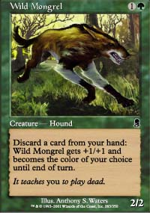
The two best commons in Odyssey are Wild Mongrel and Cephalid Looter, and as good as they've been, they both just got a lot better. Whether you're attacking and casting Arrogant Wurm on turn three or discarding Obsessive Search on turn four and drawing two cards for it, the Mongrel and Looter are both cards that would have been very, very good in other environments, but which become obscene in their present surroundings. Simply, there's very little you should be taking over either of these now. Of course, if you're sitting next to me, you're more than welcome to pass either...
8) Darker art and themes
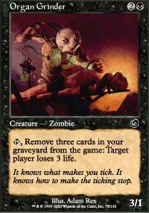
Ok, obviously this has nothing to do with Limited, strategy or an amalgamation of the two, but when you get the chance, take a good close look at the art on Boneshard Slasher, or Organ Grinder or Deep Analysis. The art in this set is great not just because of vivid imagery, but what that imagery represents. Gone are the days where religious groups fearing demonic interaction protested Unholy Strength. We're dealing with a game that depicts images of the dark but fantastical arts. The pictures ought to be pretty gnarly, don't you think?
9) The betrayal of templating
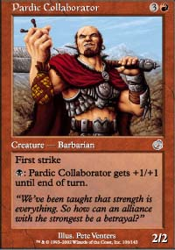
Templating, essentially, is an organizational structure for the colors. You don't make a blue elf, because blue isn't designed for explosive creature starts. That's not how it works. Templating tells us that.
With twice as many black cards as white, some of the rules for templating had to go into flux, and I think R&D did a great job of evaluating for which that is the case. The creation of red and blue cards that are only effective against white and green, where once unacceptable, now seems like a stroke of genius, representing the desires of the forces those colors represent to survive. In a world dominated by darkness, it only makes sense that blue and red creatures would lean towards the dark side themselves. If you draft black in this set, not only will you have the increased card pool, but you'll also get help from your partner color. Good luck finding synergy for white or green: you'll have to create it yourself.
10) No stupidly broken artifacts
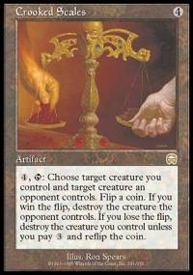
One problem with Limited has always been the random opening of power cards. This is ok when you're dealing with colored bombs, as there are decisions to be made with regards to splashing and hate drafting, but with cards like Cursed Scroll, Crooked Scales and Torture Chamber, there was no thought involved: open, pick, win.
In case you haven't noticed, Torment corrected this oversight with one sweeping decision to eliminate artifacts from the set. There isn't a single broken generic card, be it artifact or land, that changes the course of this Limited format. It's all about the colors, which means it's really all about drafting a good deck. Any steps to eliminate randomness make for a better game.
Those feel like some pretty good reasons to me. I've been drafting the set non-stop for the last couple of weeks now, and if you haven't given it it's fair shot yet, I can tell you that Torment is indicative of two irrefutable facts: Magic is getting harder, and that means Magic is getting better. Have a good week.

